Ex. No: 3.1

CONFIGURE UFW FIREWALL TO ALLOW ONLY WEB TRAFFIC (PORT 80 & 443)

Aim:
To configure a basic firewall using UFW (Uncomplicated Firewall) to allow only HTTP (port 80) and HTTPS (port 443) traffic and deny all other incoming connections.

Coding:
import java.io.IOException;

class UFWFirewall {

public static void main(String[] args) {
try {
System.out.println("Configuring UFW Firewall...");

new ProcessBuilder("sudo", "ufw", "default", "deny", "incoming").start();
new ProcessBuilder("sudo", "ufw", "default", "allow", "outgoing").start();
new ProcessBuilder("sudo", "ufw", "allow", "80/tcp").start();
new ProcessBuilder("sudo", "ufw", "allow", "443/tcp").start();
new ProcessBuilder("sudo", "ufw", "enable").start();

System.out.println("UFW configured to allow only web traffic.");

} catch (IOException e) {
System.out.println("Error configuring firewall");
}
}
}

RESULT
UFW was successfully configured to allow only web traffic on ports 80 (HTTP) and 443 (HTTPS), while blocking all other incoming connections.

Ex. No: 3.2

IDENTIFY PUBLICLY ACCESSIBLE WEBCAMS USING SHODAN.IO

AIM
To identify insecure or publicly accessible webcam streams using Shodan, a search engine for Internet-connected devices.

PROCEDURE
Step 1: Visit the Shodan website Navigate to: https://www.shodan.io
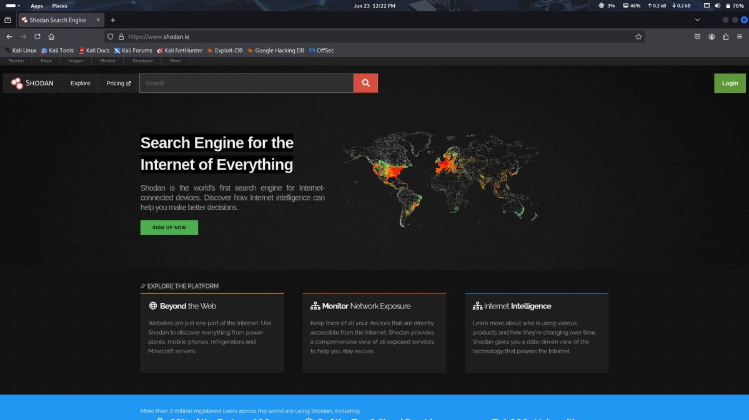

Step 2: Create a free account (if required) Sign up or log in to access search features.
Step 3: Use webcam search filters
In the search bar, use the following filters:
webcamxp or
netcam or
port:554 has_screenshot:true

Other useful queries: "webcam 7" country:"IN"
"IP Camera [Motion JPEG]" port:"8081"
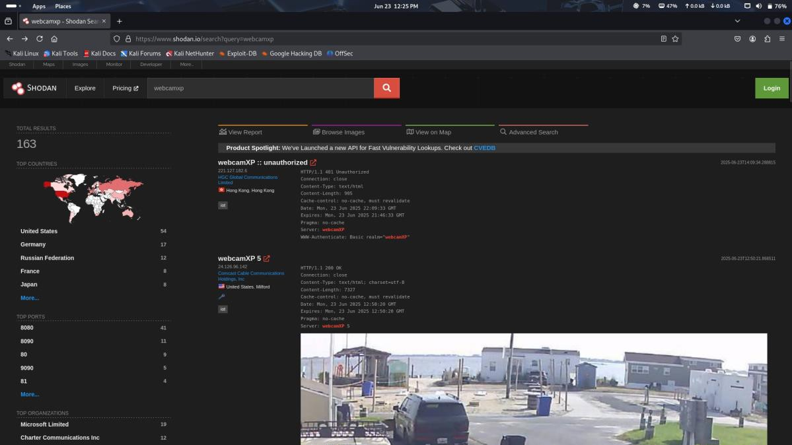

Step 4: Analyze the results
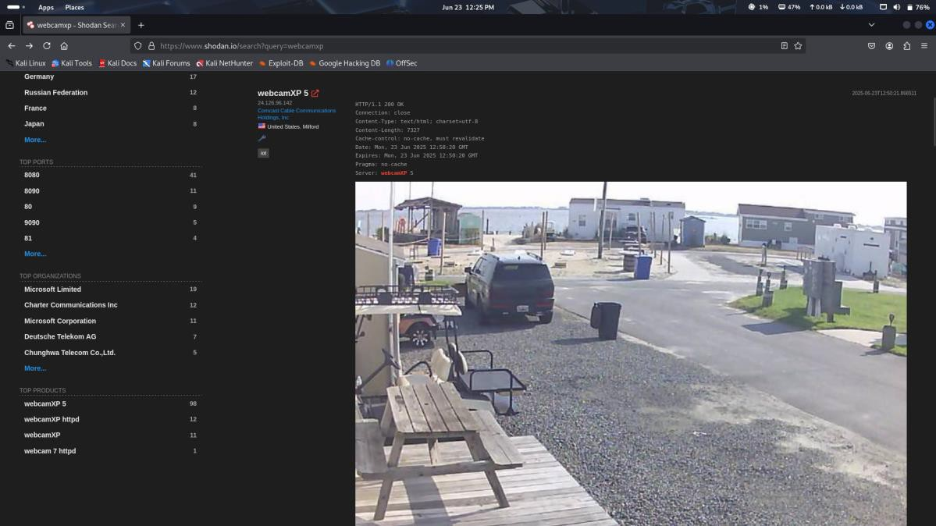
Click on the IPs to view metadata such as:
- Screenshot previews (if available)
- Location
- Port used
- Manufacturer

RESULT
Webcam streams that were unintentionally exposed to the public were successfully identified using Shodan search filters. This demonstrates the importance of securing IoT devices and disabling public access where unnecessary.

